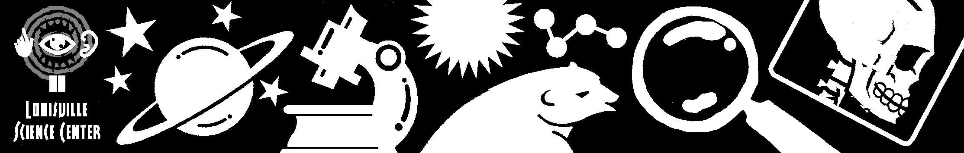

Whispering Balloons
Kindergarten Pre-Visit Activity

Guiding Question:
What can we discover about sound?

KY Core Content
SC-E-1.2.4 Vibration is a type of motion. Sound is produced by vibrating objects. The pitch of the sound can be varied by changing the rate of vibration.

KY Early Childhood Standards
K.1.1 Raise questions about the natural world.

Archdiocese of Louisville Standards
History and Nature of Science
- Work like a scientist
- Inquiry as the first step in scientific problem solving

IN Standards
Science Standard 1: The Nature of Science and Technology Students are actively engaged in beginning to explore how their world works. They explore, observe, ask questions, discuss observations and seek answers.

The Big Ideas

Energy Transformations

Context
- Sound travels through the balloon. The wave vibrations can be felt on the balloon’s surface.
- The scientific process involves observation, posing questions, making predictions, testing ideas, developing reasonable explanations, and communicating results.

The Activity:

Summary
- A balloon, when placed to the ear, can become a great sound amplifier. Students will explore the sound qualities of various shapes and sizes of balloons and develop their own questions about balloons. Students will be given the opportunity to test the questions that can be answered in the classroom.

Materials
- balloons of various shapes and sizes
- several long, narrow balloons
- large punching balloon
- large metal washers
- three hoops about the size of a Hula Hoop ®
- one Slinky ®

Procedure
- Preparation: Inflate balloons that are a variety of sizes and shapes, including some that are long and narrow. Be sure to inflate some balloons to a lesser tautness. Also, place a large metal washer in the middle of several of the long, narrow balloons – enough so that each pair of students can have one – before you inflate them.
- Begin with a short experience regarding sound. This can be a radio, or other object that makes noise, turned down low so that the children can barely hear it, or placed in a box so that the sound is audible but muffled. Ask them how they hear sound, how the sound gets to their ears, and how it gets through the box. Discuss the fact that sound travels in waves. A Slinky® can be used to demonstrate a wave. Have two students stand up and take opposite ends of the Slinky. Then, have the students move the Slinky up and down in rhythm to create a wave. Other types of waves,such as light waves or microwaves, may be discussed.
- Group the students into pairs. Tell them to have one hold up a balloon to his or her ear and the other student whisper into the balloon. Ask them for observations. Students may notice that they can feel the balloon vibrate when sound is traveling through it. If they do not notice, have them talk into the balloon while holding it between their hands. Ask them what questions they have about the balloons and sound.
- Have them trade balloons with another group so they can try multiple sizes and shapes. Ask them which ones work best. Have them trade several times. Ask them again for their questions. Ask them how they could test their questions. Have them test any questions they can, such as, “Does it make a difference if you talk into the side of the balloon rather than into the top and bottom?”
- Have the student pairs sit or stand close to each other and whisper. Then, have them move far away from each other and whisper. Ask them if they can still hear when they are far apart.
- Pass out the long balloons that have washers in the middle. Have students try to whisper to each other using this balloon. Ask them for their observations.
- Use hula-hoops to classify the balloons into Venn diagrams. Have the students come up with different ways to classify the balloons (ex: color, size, shape, best sound amplifier, most inflated, etc)
- Bring out the large punching balloon. Ask the students to predict based on what they learned today how this balloon will perform as an amplifier.

What to Look for (Results)
- When spoken into, the balloon’s membrane will vibrate as the sound is traveling through the balloon.
- Balloons with tighter membranes (more inflation) will enable sound to travel better. Balloons with loose membranes will not let sound travel as well.
- Balloons with washers will not let the sound travel. The washer stops the sound waves.

What’s happening here?
The science behind it
Sound travels in waves that are invisible to the human eye. Sound waves can travel through all matter: air, water, and solid materials. The air inside the balloon is compressed because it was forced into the balloon by your lungs or by a pump. The membrane of the balloon keeps the air compressed. Since the air in the balloon is denser than the surrounding air, sound travels better through the balloon. The spherical shape of the balloon helps to focus the sound that passes through it. The balloon membrane vibrates because the sound waves are hitting against it. Balloons that are less inflated have air that is less compressed. Sound does not travel through them as well as it does through the fully inflated balloons.

Suggested Assessment
Each student should generate a question. Questions that can be answered with the supplies on hand should be explored.

Critical Response Questions
- What did you discover about sound?
- Which balloons made the sound the loudest? the softest?
- Does your partner’s voice sound differently when speaking through the balloon? How?
- If there were no air in the balloon, could you still hear a sound?

Resources
- http://www.west.net/~science/sound.htm
- http://www.smm.org/sound/nocss/activity/3b.htm
http://chiron.valdosta.edu/djudd/soundlesson15.html

