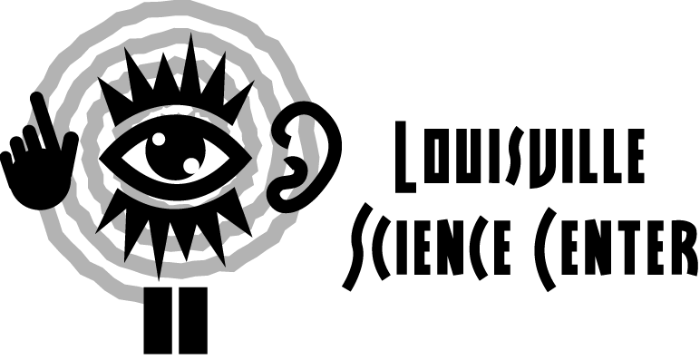

ELEMENTARY SCIENCE CENTER EXPLORATION

This guide is meant to facilitate interaction between adults and students. Find the answers to these questions with your students and see what you can discover together!

At the elementary level, students are examining what happens and why and developing explanations for them, encouraging inquiry-based learning.

Temporary Exhibit (First Floor – Main Gallery)

- Which activity or exhibit do you like most?
Why is it your favorite?

- Name another exhibit you can play with in the temporary exhibit. How do you make it work?
What happens when you play with it?

- Why do you think the exhibit has the name it has?
Can you think of another name for the exhibit?

THE WORLD WE CREATE (Second Floor)

- Find Grateful Gears next to the Chemistry Kitchen. Turn one of the knobs. In which direction did you turn the knob?
Do all the gears turn in the same direction?
Can you think of anyplace where you have seen gears before?

- Let’s go to Just in Time in Tech Works. How many products did you complete?
What do you think you can change about what you are doing in order to make more products?

- Let’s find the Inventor’s Challenge in the Inventor’s Garage. Put the long pieces called pipes through the wooden holes and connect them with the short pieces called joints. Now put one of the wooden balls in one end of the structure you made. Does it come out of the other end? Why or why not?
What can you change to make the ball come out or come out a different way?

- Go over to Toppling Towers in the Think Tank. Build something with the blocks. Now press a button. What happens to your blocks?
Does your structure withstand some forces and not others?
Why do you think your structure fell?
What can you do to keep it from falling when you press the button again?

- Did you watch something fun in the Chemistry Kitchen? What did you see?
Did you find out something you didn’t know before?
What was it?
Did the educator explain something you already knew?
What was it?

THE WORLD WITHIN US (Third Floor)

- Let’s go to the BodyWatch Gallery. Do you see any parts in the gallery that look like parts of your body?
What do those parts do?
Where do you see parts that look like bones?
Do you know what your heart looks like?
What about your stomach?
Your spinal cord?

- Let’s look at the LifeSpan Wall in the TimeZone Gallery. Do you see anyone who could be a mommy or a daddy?
How about a brother or a sister?
Who looks older than you do?
Who looks younger?
How are some of the people like you?
How are they different?

- Let’s explore the rest of the TimeZone Gallery. What happens when you step into the Tune Into Life exhibit?
What game did you play or activity did you try?
How do you play it or do it?
Is it different from doing it somewhere else?
How is it different?

- Find the Time Machine exhibit in the TimeZone Gallery. What might you look like in 20 years? 40 years? 60 years?
In what ways are those pictures different from the way you look now?

Extended Science Center Exploration Questions

- Name something fun that you did at the Science Center. Tell your friend how it works.

- Make a list of all the things that we can remember from our visit to the Science Center.

- Draw a picture of your favorite thing at the Science Center.

- Pretend that you work at the Science Center. What job would you like to have?
What are some of the things you would tell the students who come to visit us?

