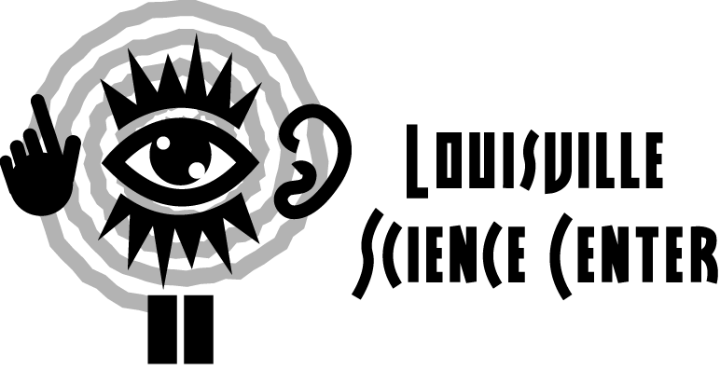

Science Center Exploration

This guide is meant to supplement science learning achieved in a classroom setting. Students should work independently with guidance from instructors.

Students will investigate what happens and hypothesize why things happen with their exhibit interaction. They will also be called upon to find scientific relationships between the exhibits themselves and between the exhibits and the real world.

Temporary Exhibit (First Floor – Main Gallery)

- Go to the temporary exhibit on the first floor. What is the main idea of the exhibit?__________________________________________________

- Visit a part of the exhibit that looks interesting to you and find out how it relates to the main idea.

- Have you ever seen anything in real life that reminds you of the exhibit you chose?
What was it? _______________________________________________________
How are they alike?__________________________________________________

- How would you describe the traveling exhibit to a friend?______________________________________________________________

THE WORLD WE CREATE (Second Floor)

- Did you see a demonstration or do an activity in the Chemistry Kitchen? If so, what was it?
What new science idea did you learn from it?____________________________________

- Experiment with one of the Physics Boxes in THE WORLD WE CREATE. Notice what happens before and after you interact with it. What did you observe after trying out this exhibit? _______________________________________________________________

- Find another Physics Box and try it out. How is this Physics Box similar to or different from the first one you worked with?________________________________________________

- Go to Building Bridges (the arch). What do you have to do to build the arch?
Which block do you think is the keystone?_________________
Why do you think it is so important?_____________________________________

- Notice inventors represented throughout THE WORLD WE CREATE. Choose one and describe what he or she invented. Describe what life would be like without that invention.
___________________________________________________________________________

THE WORLD WITHIN US (Third Floor)

- Find the Cardiovascular System or the Musculoskeletal System in the BodyWatch Gallery. What parts of the system do you recognize?
How do these parts work?___________________________________________________

- Try one of the exhibits associated with the system you chose and describe how it works.
How is this exhibit related to the system?_______________________________________

- Go into the TimeZone Gallery and challenge yourself with Out of Control. What facts did you learn from this activity? ________________________________________________
How can these facts help you in your life? _____________________________________

- Find Tune Into Life in the TimeZone Gallery. Which activity did you do?
How is participating in this activity using virtual reality different from doing the activity in real life? _____________________________________________________________________
Can you think of ways in which using virtual reality could help you in the real world?

- Visit a hands-on demonstration in the BioLab. What was the demonstration about?
Why do you think it is important to know about the subject the educator covered in the demonstration? ___________________________________________________________

Extended Science Center Experience

- Name something that you learned today on one of the floors and tell why it is important.

- If your friend was visiting the Louisville Science Center, what would you tell him or her not to miss?
What do you think he or she would learn from it?

- If you worked at the Louisville Science Center, what would you tell the students who visit?

- Can you think of a way in which an exhibit on one floor is related to an exhibit on another?

- Is there something that you did today that is related to what you do everyday?
What is it and how is it related?

