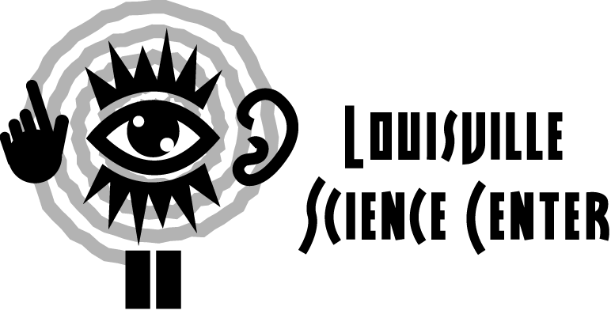

Primary Science Center Exploration

This guide is meant to facilitate interaction between adults and students. Find the answers to these questions with your students and see what you can discover together!

At the primary level, students examine and analyze what happens, improving their observation and prediction skills.

KidZone (Groups must make reservations one week in advance for KidZone.)

- Did you have a good time in KidZone?
What was your favorite thing to do?
Tell a friend about your favorite thing to do in KidZone.

- Did you get to have a job in KidZone?
What was it?
Did someone help you do your job?

Temporary Exhibit (First Floor – Main Gallery)

- What is the biggest thing you see in the temporary exhibit?
What’s the funniest?
Which activity or exhibit do you like most?

- Name another exhibit you can play with in the temporary exhibit.
How do you make it work?
What happens when you play with it?

- Does anything move around in the exhibit?
What is it?
What does it do?

THE WORLD WE CREATE (Second Floor)

- Find Grateful Gears next to the Chemistry Kitchen. Turn one of the knobs. Which direction did you turn the knob?
Do all the gears turn in the same direction?
Find a gear that is your favorite color and see which way it turns.

- Let’s find the Inventor’s Challenge in Inventor’s Garage. Put the long pieces, called pipes, through the wooden holes and connect them with the short pieces called joints. Now put one of the wooden balls in one end of the structure you made.
Where does the ball go?
What can you do to make the ball come out of the other end?
Add some more pipes and joints. Does the ball go a different way?

- Go over to Toppling Towers in the Think Tank. Build something with the blocks. Now press a button. What happens to your blocks?
What happens when you build your blocks into a different shape and press the button again?

THE WORLD WITHIN US (Third Floor)

- Let’s go to the BodyWatch Gallery. Do you see any parts in the gallery that look like parts of your body?
What do those parts do?
Where do you see parts that look like bones?
Do you know what your heart looks like?
What about your stomach? Your backbone?

- Let’s look at the LifeSpan Wall in the TimeZone Gallery. Do you see anyone who could be a mommy or a daddy?
How about a brother or a sister?
Who looks older than you do?
Who looks younger?
How are some of the people like you?
How are they different?

- Let’s explore the rest of the TimeZone Gallery. What happens when you step into the Tune Into Life exhibit?
What game did you play or activity did you try?
How do you play or do it?

Extended Science Center Exploration

- Name something fun you did at the Science Center. Tell your friend how to do the same thing.

- Make a list of all the things that we can remember from our visit to the Science Center.

- Draw a picture of your favorite thing at the Science Center.

- Pretend that you work at the Science Center. What are some of the things you would tell the boys and girls who come to visit us?

